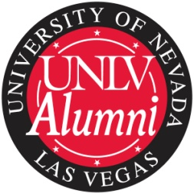
UNLV Alumni Association Chapter Program
Chapters in Good Standing Annual Report
Annual reports are required of all the chapters. Deadline for submission is September 1 each year. Please send to Amy Bouchard Brooks at amy.brooks@unlv.edu.

Chapter Name:
President:

Board Members as of June 30.
Name: Position:
Name: Position:
Name: Position:
Name: Position:
Name: Position:
Name: Position:
Name: Position:
Name: Position:
Name: Position:
Name: Position:
Name: Position:
Name: Position:
Name: Position:
Name: Position:

Date of last election: Date of next election:

About the Chapter
Total graduates covered by the chapter:
Number of chapter members as of June 30:
Number of chapter members as of June 30, last year:
What is your chapter’s membership goal for next year:

- Explain what your chapter’s participation in the following events: Homecoming Dinner, College Alumnus/a of the Year, and Dinner with a Rebel.
- Please provide a summary of activities undertaken by your chapter during the last fiscal year including events hosted, membership recruitment, and alumni communication.
- Please attach copies of board meeting minutes, newsletters, and your chapter’s strategic plan.

Signature __________________________________________________ Date _____________________

